ASSIGNMENT- S3 BUCKET

Task: Create a lambda function to start, stop and terminate a running EC2 instance. Also, verify the logs generated by the lambda in the Cloudwatch logs to check whether the lambda execution is done properly.

Steps-

1.Create an instance

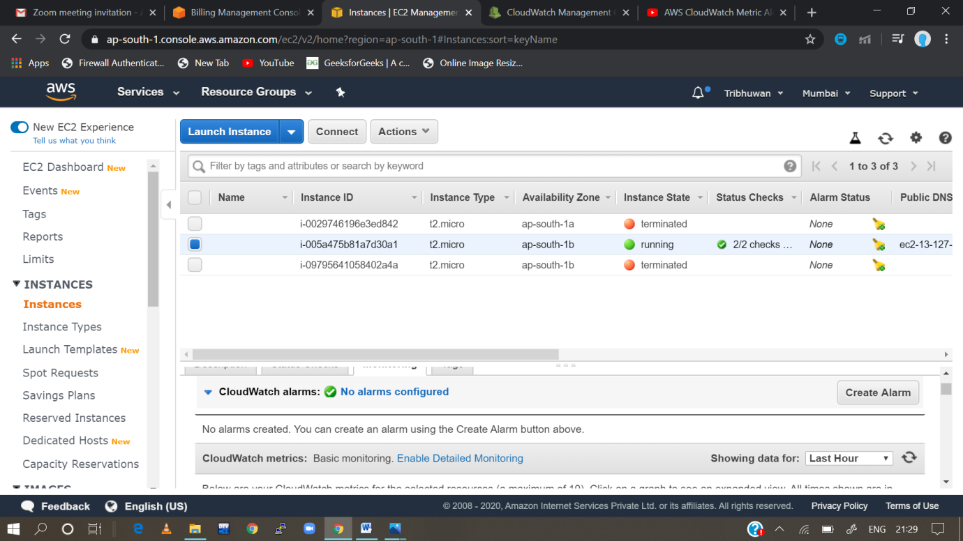

2. then go to monitoring and check cloud watch alarms and go to “No alarms configured”

Step-3: then go to create alarm

Step-4 configure the alarm settings

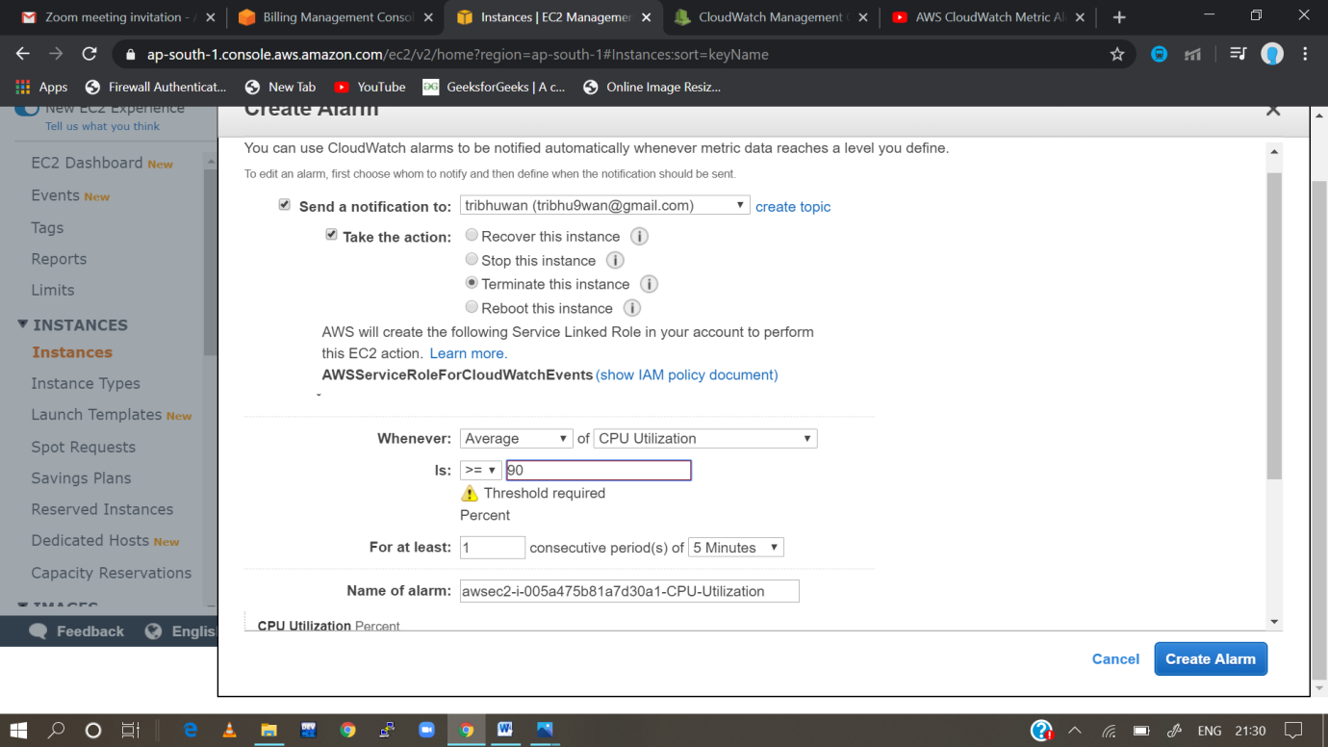

Step 5: Alarm set successfully.

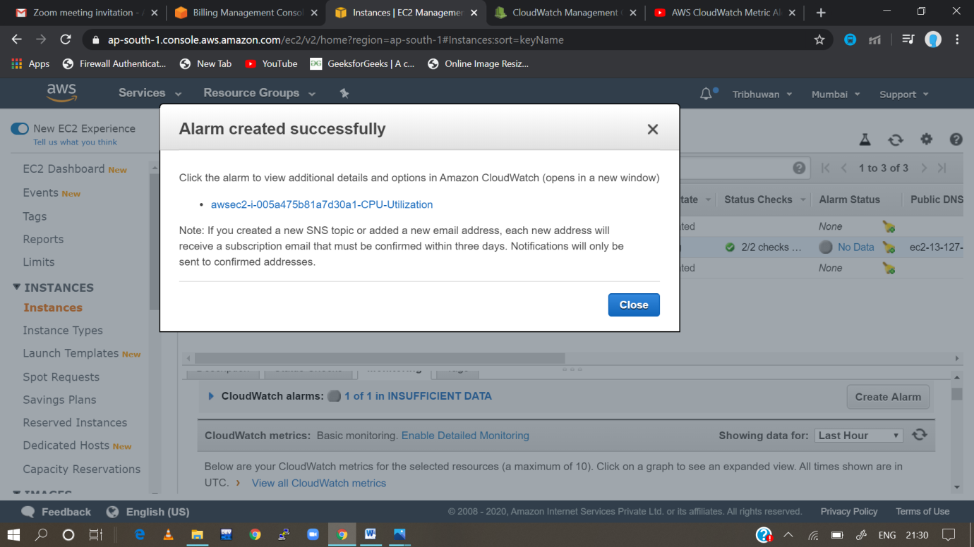

Task 2: Create a lambda function to send an email notification to your email id of your AWS account, as soon as you delete a file from an S3 bucket, mentioning the file name which is deleted.

Steps: First of all, we create a role which is a temporary access

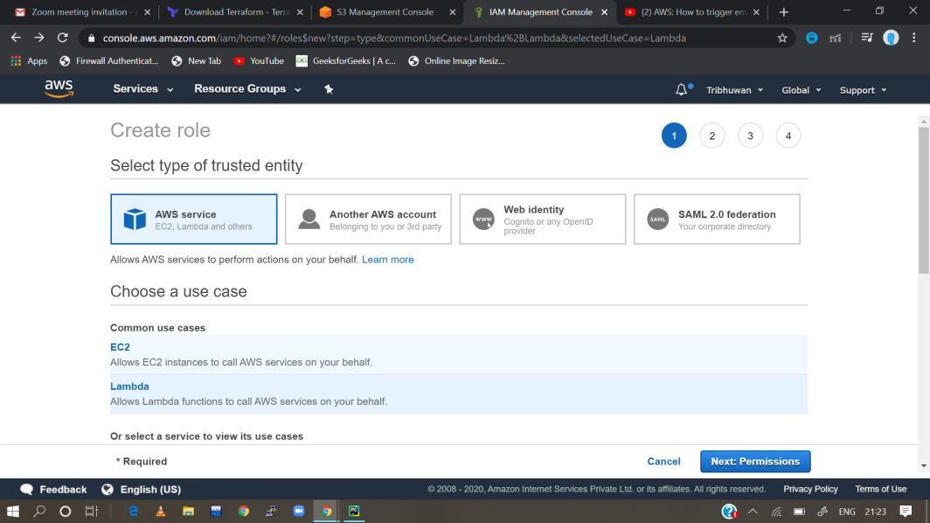

2.then choose lambda and go to the next permission

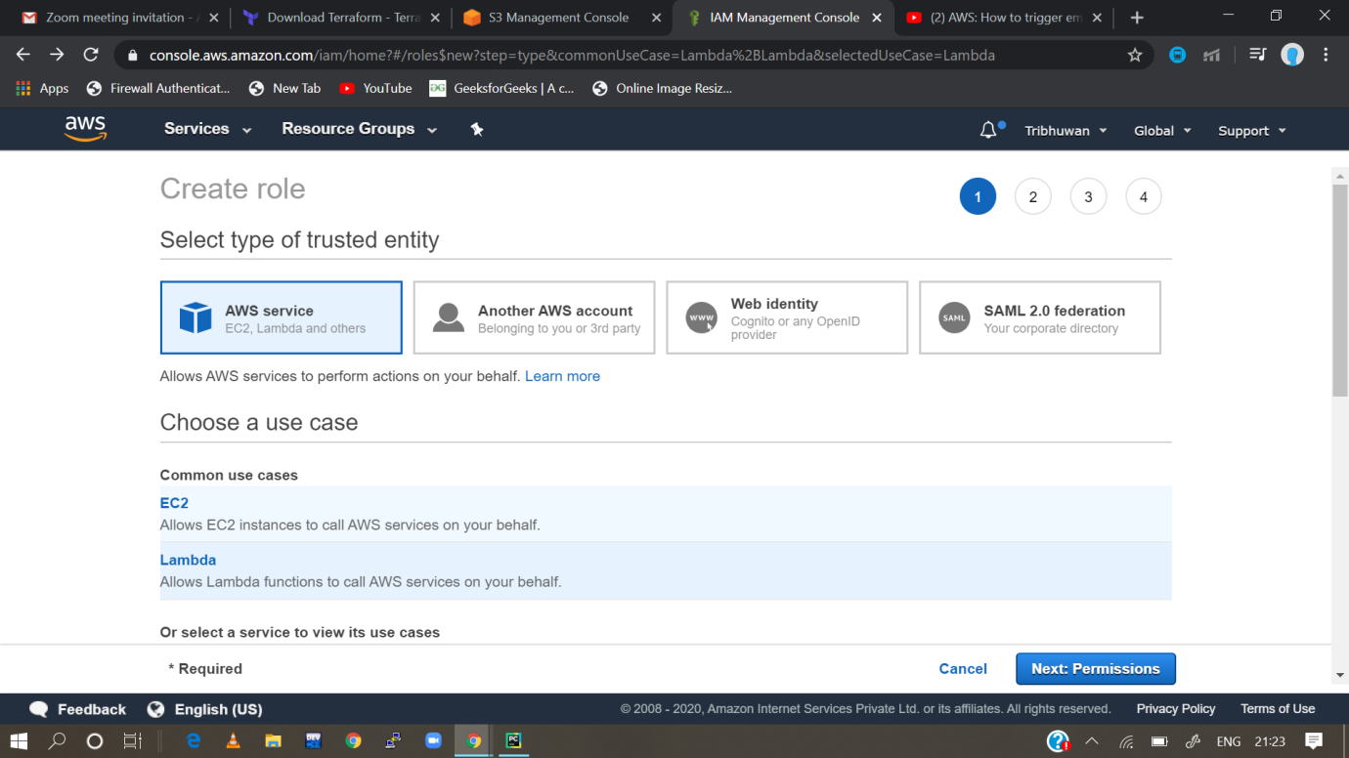

3.then attach the permission policies

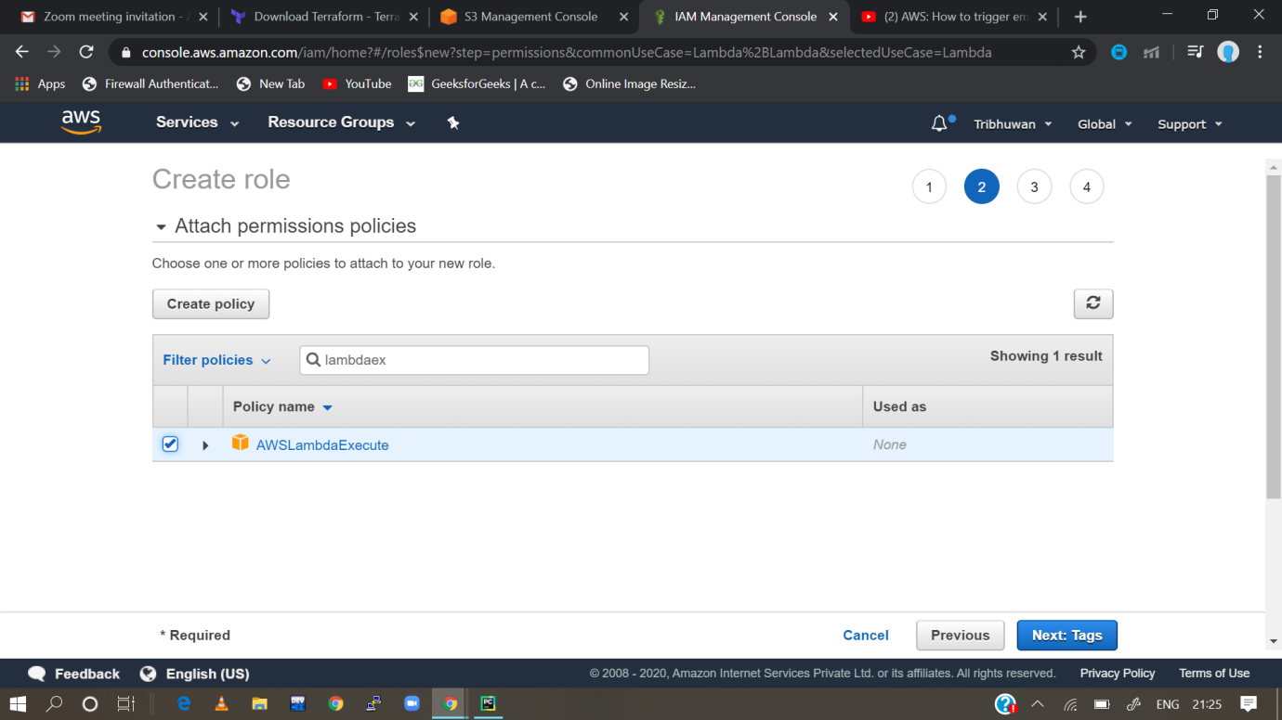

4. review your role and then create the role

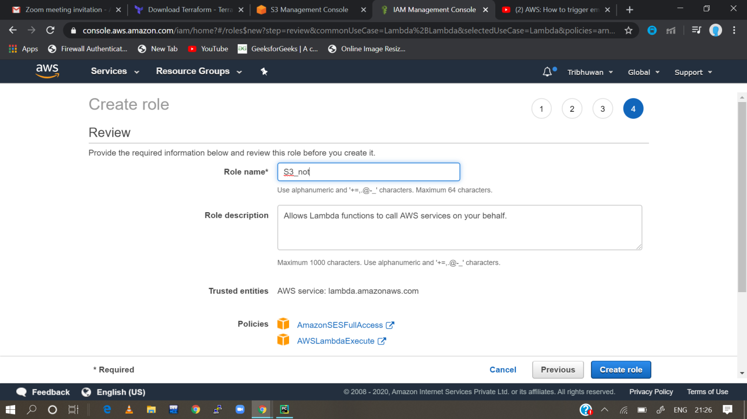

5. now role is created then we go to create bucket, but bucket is already existing, so we use the existing bucket

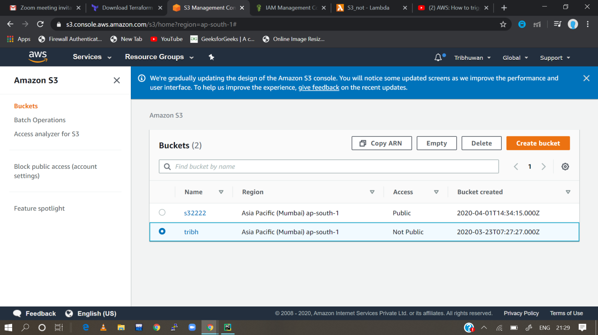

6. then we go to the properties of the existing bucket

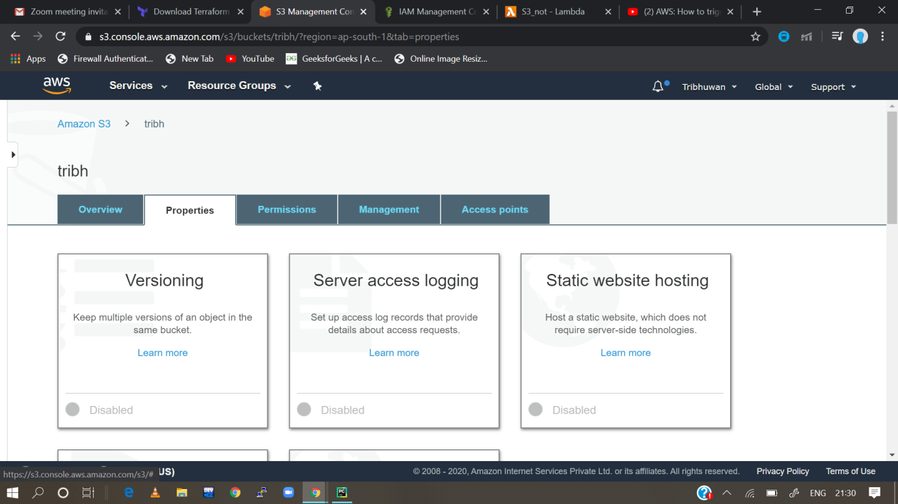

7. then we choose the events i.e; all object delete events

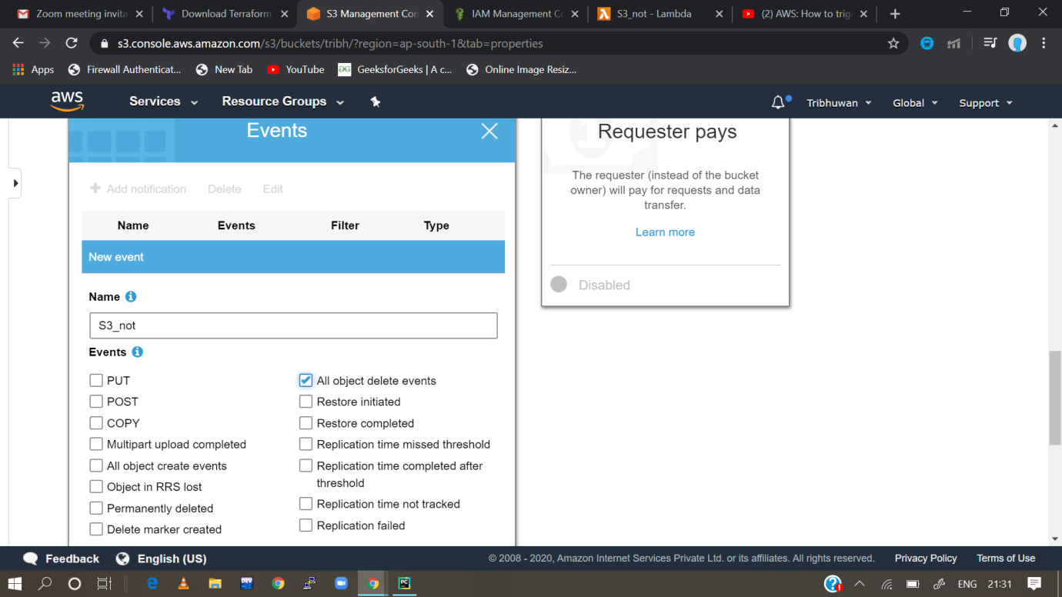

8.then go to lamda function and write the access code for the notifying mail for deleting any files from the s3 bucket

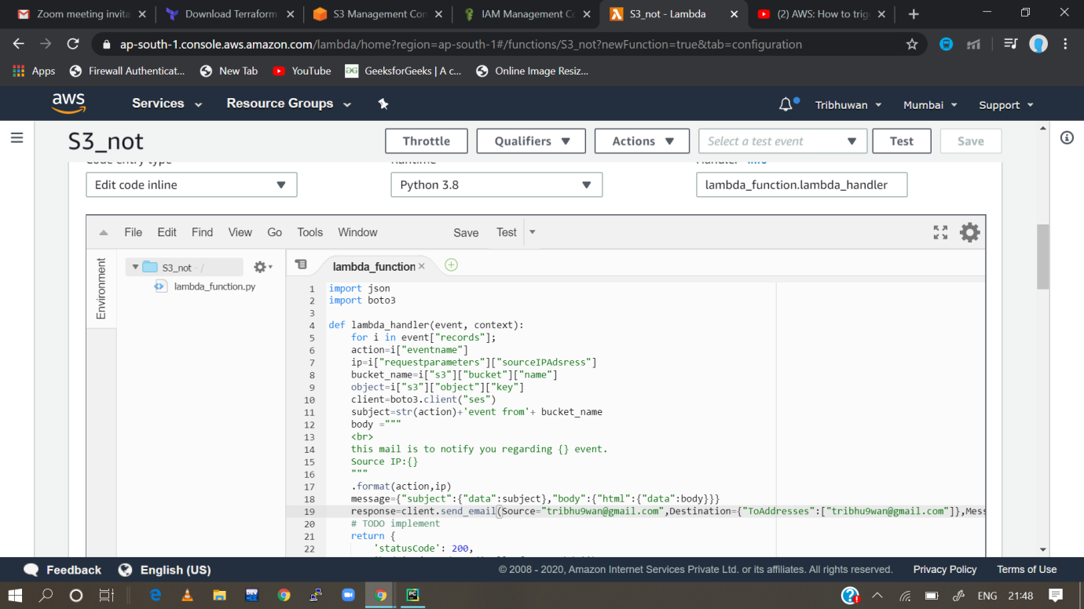

9. Delete the files from the bucket

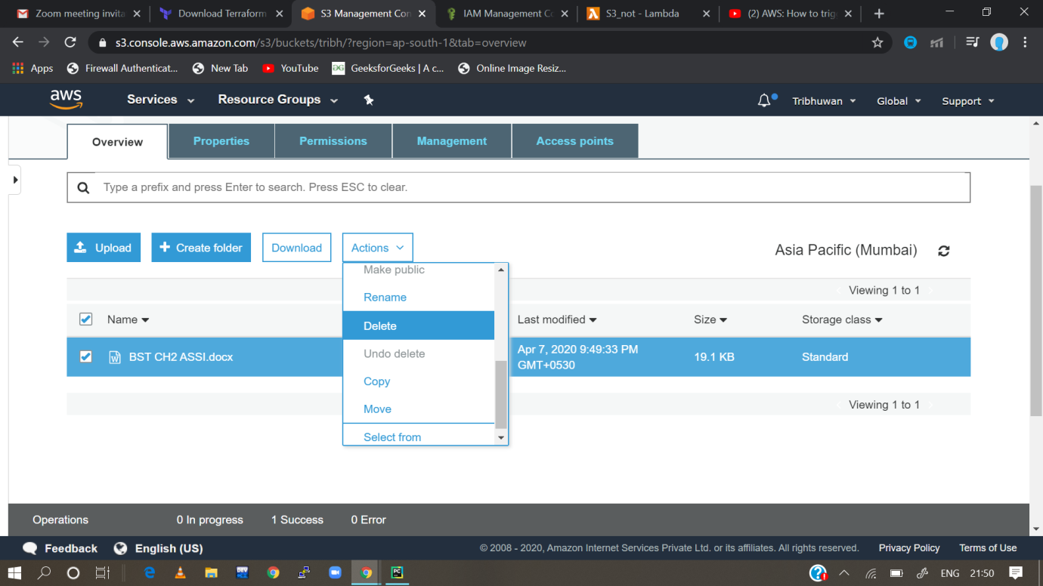

10. go to simple email service to verify the email

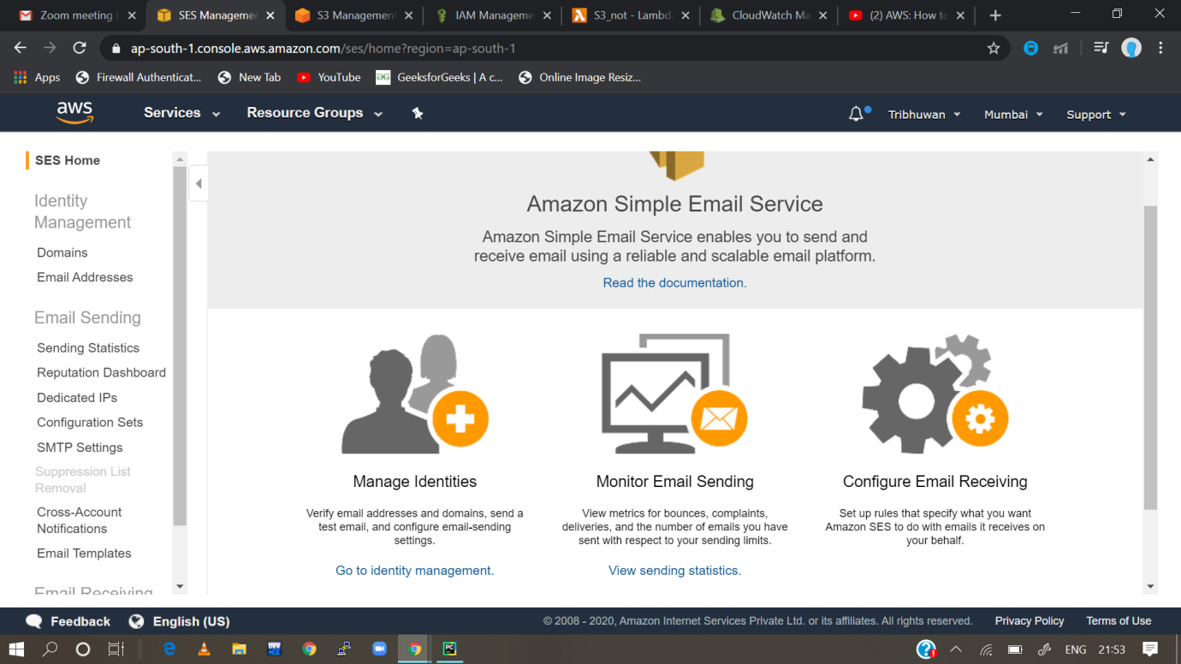

11. then go to cloudwatch and check whether deleting notification is accessing or not

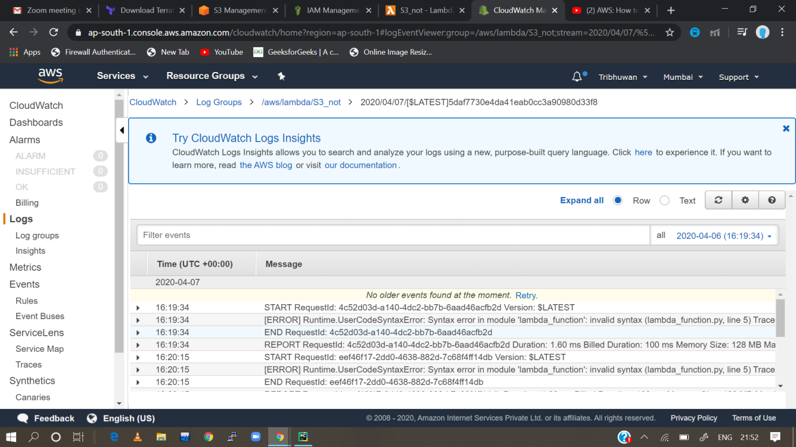

12. If it is accessing then check the emails otherwise check the functions again and perform the same tasks again